Model Predictive Controller for DHW storage tank and Heat pump

WP4 Document

# Introduction:

This document describes the activities and results of the 4th work package in the project Open-source Energy manager. While WP1 dealt with the package of requirements, WP2 with the selection of tools and publishing platform, and WP3 with the system architecture, this WP deals with the design, realization and test of the energy management system. In this document, various terms are used, defined below.

**Plant**: The plant consists of solar panels, an air-water heat pump, a boiler tank for domestic hot water, and their interconnections.

**MPC**: The model predictive controller, or simply the controller ensures the tank temperature is kept within the required values. The controller achieves this goal in an “optimal manner”. To do so, the controller solves an optimization problem which includes an objective function (optimal condition), equality constraints (the plant dynamics), and inequality constraints (physical limits of the plant).

**Weather prediction module**: This module is responsible for supplying the controller with forecasts of the solar irradiation and ambient temperature.

**Actuators**: The actuators in the plant are the electric heating element and the heat pump compressor.

**Energy management system**: The controller and the weather pre- diction module together are referred to as the energy management system.

**Disturbances**: By definition, these are variables that affect the plant performance but can't be manipulated. The measured disturbances include the solar irradiation, ambient temperature, the hot water usage profile, and the temperature of the return cold water.

Activities this WP:

1. Literature research on the following topics: heating system layout, software tools for HVAC modelling and controller design, and advanced control strategies in HVAC.
2. System Layout: The system layout: Heat generation, transport, stor- age and delivery will be explained.
3. System's modelling: Developing a dynamic model for the system described in (2).
4. Internal model development: Developing a state space representation of the system. This will be used an internal model for the MPC.
5. Model-predictive Controller (MPC) design.
6. MPC testing in Simulink.
7. MPC implementation in Python.

# Literature Review:

In this section, a literature review is carried out to find what is the system layout for a heating system that incorporates a heat pump, a buffer tank and daily hot water usage. The system layout describes how the heat generation equipment (Heat pump, gas boilers, electrical heaters) are connected to thermal storage tanks, and how the generation and storage equipment are connected to the heat delivering equipment. In [1], a system with a ground-source heat pump, a stratified storage tank and an auxiliary heater is considered. The system layout is shown in figure 3.

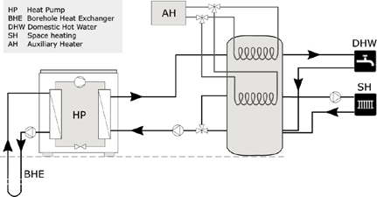

Figure 1: System Layout reported in [1]

It should be noted that the study [1] was carried out in Sweden, where ground-source heat pumps are dominant, as opposed to the Netherlands where air-water heat pumps are most commonly used. Furthermore, the use of a stratified tank may not be suitable for the purposes of a refurbished house in the Netherlands, as conversations with experts (Quote: Rob Ter Steeg in HPLaunch) and practitioners point out that finding a suitable space for the stratified tank is challenging.

An alternative system layout is also presented in [1] and shown in the figure below. The authors argue that this system layout is more suitable for variable speed compressor heat pumps. In this layout, the storage tank is only used for DHW purposes. Therefore, the tank need not be stratified.

Various other system configurations have been reported in literature. In [2], the system configuration consists of a PVT, heat pump and two storage tanks. In [3], the system consists of an air-water heat pump in parallel to a gas boiler. Other examples of various system layouts are reported.

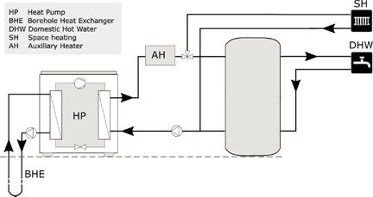

Figure 2: An alternative system layout option [1]

It becomes clear that any system configuration is greatly influenced by the geographical location of the building, the type and insulation level of the building, the country's regulations, and the profile of the thermal demand in the building. For these reasons, a better approach to arrive to a system configuration would be to consider the specific building for which the application is intended, propose a system layout based on the load profile and the available equipment, and discuss the proposal with experts, manufacturers and installers.

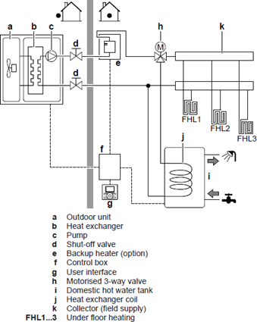

Figure 3: System Layout proposed by Dakin [4]

DAKIN industries is one of leading manufacturers of heat pumps with a large market share in the Netherlands. The Figure 4 is extracted from a DAKIN reference guide l4j for an air-water heat pump comparable to the size of the heat pump developed in HP-Launch. In this configuration, the heat pump is the main heat generation source for both space heating and DHW. When the heat pump cannot meet the de- mand, due to defrosting or unfavorable weather conditions, a backup heater is used. The results from project HP-launch (citation needed) indicate that without a heat storage medium, there is no room for optimizing the heat pump operation as the heat pump will be operating at its maximum for the entire time.

## Modelling & Controller Design Software tools:

The design of an advanced control strategy requires a model of the controlled process. Heating, ventilation, air-conditioning and cooling (HVAC) of buildings has been a field of study for over 40 years. As a result, there exists a wide range of software products for simulation of the energy performance of buildings. In [5], an overview of these products is provided. In [6], simulation tools are divided into several categories. This can reduce the burden of selecting a simulation tool. The categories are:

* Tools for pipe/duct sizing.
* Tools for equipment sizing and selection.
* Tools for energy performance analysis.
* Tools for system optimization.
* Tools for control analysis and control optimization.

It's clear that the tools that belong in the final category are the ones of interest for the purpose of this project. In order to find out these tools, a search tool (BEST) l7j created by the US department of energy is used. The directory of all HVAC software can be searched based on capabilities. The search results show that the most prominent software products under this category are ESP-r l8j , EnergyPlus l9j and TRNSYS l10j. In l11j and l12j a comparison is made between the performance of TRNSYS and EnergyPlus, the findings show that both tools provide similar results that agree with experimental data. For the purposes of this project, EnergyPlus is preferable because it is an open source platform.

Although the tools mentioned above offer high degree of sophistication and detail in terms of thermal energy performance, they do not provide capabilities for advanced control systems design comparable to, for example MATLAB. On the other hand, MATLAB provides an efficient platform for the design of advanced controllers, yet has limited capabilities in simulating building systems thermal performance.

Co-simulation has recently been exploited as a way to combine the strength of two software tools in order to execute. For example, using EnergyPlus to simulate the plant and MATLAB to to simulate the controller, while data is being passed between the two at each sampling interval, as explored in l14j.

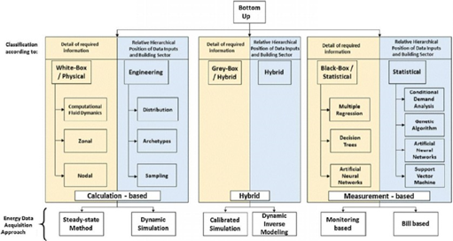

Figure 4: HVAC Modelling approaches [13]

## Control Strategies:

Broadly speaking, building control strategies can be classified into rule-based strategies and model-based strategies l15j. The figure below shows a classification of these control strategies.

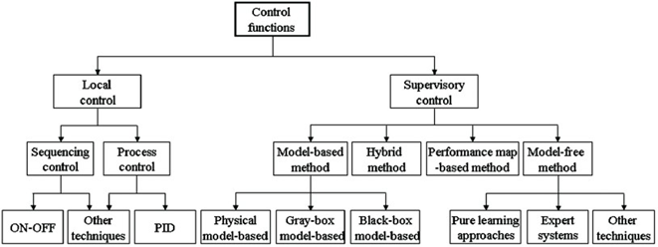

Figure 5: Classification schematic of control functions in HVAC systems.l16j

There is hardly any scientific literature published on the rule based methods. This could be due to the fact that they are developed by heat pump manufacturers and considered propriety. However, it is understood that the rule-based methods rely on the heat-pump heating curve, ambient temperature and threshold values in an 11if-condition-then-action11 fashion l17j.

Mode-based strategies has been reported in literature since as early as 1990. In l18j, a comprehensive review of Advanced control systems engineering for energy and comfort management in a building environment is offered, which references over a hundred articles on the subject.

Despite the extensive research and promising results, advanced control strategies in built-environment did not find their way into commercial application. This is attributed to the higher computational power required compared to rule-based techniques, the extra sensors, and the need of an accurate model of the house, which makes it difficult to adapt to the different characteristics of each household. A comparison between rule-based and model-based methods is summarized in l15j and presented in the table below.

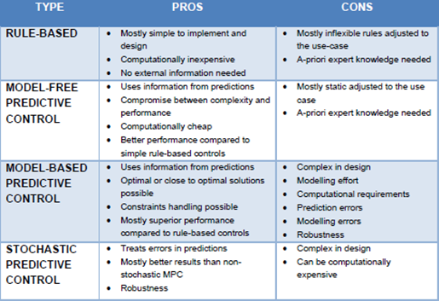

Figure 6: Summary of pros and cons of contol strategies applied in built- enviroment.l15j

# System Description:

The ongoing activities in parallel work packages (See activity reports WP1, WP2 and WP3) have so far resulted in various decisions regarding software, firmware and hardware. Among these decisions is the system architecture. The system's P&ID is shown in the figure 8.

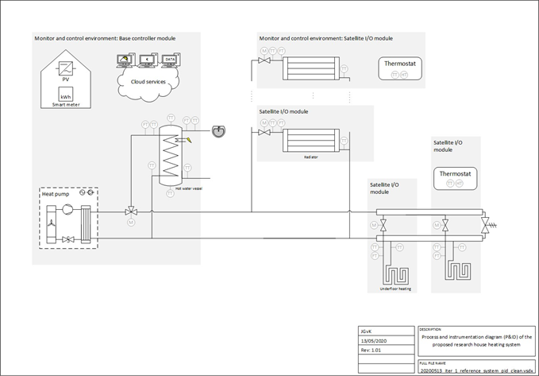

Figure 7: System Layout

This architecture is consistent with the reviewed literature. As depicted in the figure, the main heat source in the system is the heat pump. The heat pump includes a booster (not shown in the figure). The booster is an electric heater that can be used to supply heat when the output of the heat pump cannot meet the demand, or when the heat pump is in defrosting mode, or when the heat delivery device (e.g. radiators) require higher temperature than the heat pump can deliver.

A three-way valve controls the ratio of the heat that is delivered to the space heating devices (Radiators and underfloor heaters) and the water storage tank. The water storage tank is responsible for delivering the daily hot water (DHW) demand. Note that the storage tank includes an electric heating elements whose purpose is to meet the DHW demand when heat pump is in defrosting mode, and to maintain the water temperature according to the minimum required by the health regulations.

The presence of a storage tank is crucial for the system as it allows for optimization. Clearly, without storage the instantaneous heat demand need to be generated on the spot. Storage also allows for the energy manager to make use of predictions. This will be elaborated in later sections. Two types of heat delivery devices are depicted in this system layout; radiators and underfloor heaters. The design of the energy manager will assume the presence of both devices. The reason is that the reference house selected for this study uses radiators. However, refurbishments allows for replacement of the radiators with underfloor heaters, which requires less fluid temperature compared to the radiators. In addition, underfoor heaters have a higher heat capacity, this property can be exploited as means of heat storage.

# Plant Modelling:

As mentioned in section 2.3, the design of a predictive energy management strategy (model predictive controller) requires a dynamic model of the plant. This dynamic model is run by the MPC internally to to predict the future states of the plant as depicted in the figure below.



Figure 8: Structure of the Model-predictive controller

The plant is divided into subsystems. Namely: the solar panels, the heat pump, the heat exchanger and the buffer tank. The following sections present the dynamic model of each subsystem.

## 4.1 Solar Panels model:

The electric power generated by the roof solar panels [*W* ] is given by:

Where is the number of the solar panels on the roof. [ W/m2] is solar irradiation. ) is the efficiency of the solar panel. Due to the semiconductor properties of the photovoltaic cell, its performance decreases with temperature, this effect can be characterized by:

Where is the reference efficiency. is the temperature coefficient. The values of and βref are given by the manufacturer at = 25[C]. is the cell temperature, which can be estimated by the approximation:

Where is the ambient temperature. is the nominal operating cell temperature, which is defined as the cell temperature measured under open-circuit when the ambient temperature is 20 [C], irradiation is 0.8 [kW/m2] and wind speed is 1 [m/s].

## Heat Pump Model:

Dynamic modelling of heat pumps has been the subject of many publications (add citations), including project HP-Launch by this research group. The model structure and the level of detail depend on the goal of the model. For the purpose of the model predictive controller, the goal of the model is to estimate the temperature of the condenser outlet as a function of the com- pressor power and the ambient temperature. Therefore, the internal phases of the heat pump refrigerant will not be modelled. Moreover, when considering the time-scale of the controller, the internal states of the refrigerant) become irrelevant.

The coefficient of performance of a heat pump is defined as the ratio between the heat delivered by the heat pump [W], to the work performed by the heat pump compressor [W].

According to Carnot cycle efficiency, the COP can also be obtained by:

Whereand [C] are the temperatures of the condenser and evaporator, respectively. Note that the expression above gives the theoretical maximum COP. Practically, under the same conditions, the COP will be below this value, due to heat losses.

In [20], the Coefficient of Performance (COP) from over 100 domestic heat pump models was collected, along with the temperature rise across the heat pump. Curve fitting was used to obtain a relationship between the COP and the temperature difference as shown in the figure:

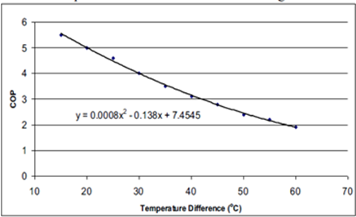

Figure 9: Relationship between COP and condensor/evaporator temperatures [20]

Now that the COP is characterized in terms of the evaporator and condenser temperatures, what is left is to describe the dynamics of the evaporator and condenser. These dynamics can be modelled via the heat balances depicted in figure 11

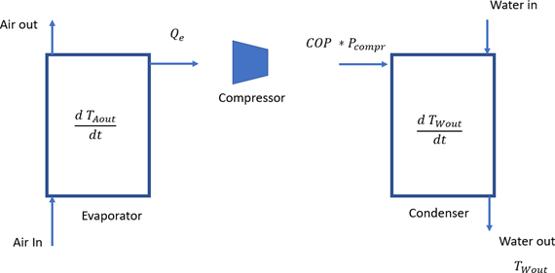

Figure 10: Heat balance in a typical air/water heat pump

Thus, the heat balance of the evaporator can be written as:

Where [*J/K*] is the heat capacity of the evaporator. *Tain* and *Taout* [*K*] are the temperatures of the air entering and leaving the evaporator, respectively. [*Kg/s*] is the mass flow rate of the air through the evaporator. [*W* ] is the rate of thermal energy delivered by the evaporator. Note that the last term can be rewritten as:

Similarly, from the figure above, the heat balance of the condenser can be written as:

The set of equations presented above characterize the heat delivered by the heat pump as a function of the ambient temperature and the compressor power.

## Storage Tank Model:

The water tank represents the storage element in this system. Thermal energy is added to the storage via a spiral heat exchanger. Hor water can be extracted for DHW use from the top of the tank, while cold water is added from the bottom to maintain constant water volume. The layout of the storage tank is shown in the figure

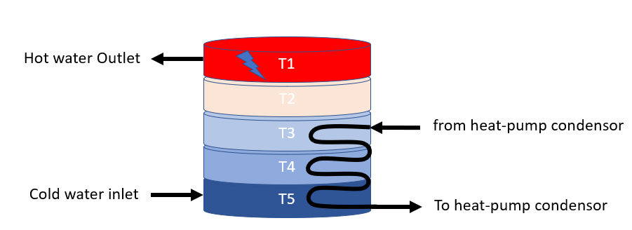

Figure 11: Layout of the storage tank

A distinct property of such storage tank is the *stratification* of water; Due to the fact that the density of water decreases as its temperature increases, the warmer the water the higher up the tank it moves. This creates distinct “layers” of water with different temperatures inside the tank. Although this is desired from a storage perspective (Maintaining the higher layers at higher temperatures without the need to heat up the lower layers), stratification introduces complexity to the dynamic model.

An approach to model the stratification behavior is to assume the tank is divided into several layers as shown in the figure, with each layer having a single temperature, and work out the heat balance for each layer independently. This is known in the literature as a 1-D model, as opposed to more complex models that assume the temperature is not only distributed vertically, but also in the other coordinates.

The main choice is then the number of layers within the tank. Clearly, The higher the number of layers chosen, the more accurate the stratification effect is captured. However, this comes at the expense of the number of equations required (For each layer, one differential equation). Considering the model will be used as a predictive model in the MPC, a highly complicated model is not desired from a computational expense point of view. Furthermore, if the temperatures are not measured withing the tank, an estimator is needed to provide the temperature values.

Therefore, the choice for the number of layers is the minimum number of layers capable of providing a model that can estimate the *energy content* of the tank with sufficient accuracy. After consulting with TNO, who conducted simulations with different number of layers, the choice is 5 layers. The storage tank was subsequently equipped with 5 thermocouples as well.

The heat balance equation for one layer of the tank can be written as:

In the next section , each term in the balance will be elaborated.

### Conduction:

Conduction is the heat transfer between adjacent layers in the tank. This can be elaborated for layer 1 as:

Where is the Heat conductivity times area [W/mK ]. And dx is the length of the layer [m]. For the layers 2 to 4:

And finally, for layer 5:

### Convection:

Convection is the unidirectional heat transfer due to the movement of warmer water from the bottom layers upwards. The time constant of convection dynamics is much faster compared to the other heat transfer terms in the balance equations. Therefore, modelling the dynamics of convection in the form differential equations will force the choice of a very small sampling time in the simulation. This will cause the prediction algorithm to become inefficient.

Instead, the convection will modelled “statically”. First, the temperature of each layer is calculated from the heat balance equation, excluding the convection term. Then, a check will be made to find where *inversion* occurs (Inversion refers to the unrealistic situation in which a layer will have a higher temperature than the one of the layers above it). This check can be made with the following pseudocode:

for i = 4:-1:1

if T(i+1) >= T(i)

inversion_Index = i+1;

break;

end

end

If no inversion is present, then no heat transfer due to convection will take place. However, if inversion is detected, then is calculated using the following equations:

And:

For the unaffected layers (below the inversion),

### Heat Loss:

The stationary heat loss refers to the heat loss from the water in the tank through the tank walls to the surrounding environment. This is characterized by:

Where N is the number of layers in the tank. is the ambient temperature outside the tank. is the temperature of layer n. is the external surface area of the tank, and is the heat loss coefficient of the tank surface [W/m2K].

### Tapping:

Tapping refers to the change of the thermal energy content of the tank due to extraction of DHW and simultaneously adding cold water at the inlet. For the lowest layer, where cold water is added, this change in energy is captured by the equation:

And for the layers 1 to 4:

### Heating:

Heating refers to the thermal energy added to the tank via the heat exchanger coil that runs through layers 3 to 5. Here, it is assumed that the coil itself is divided into 3 sections (A,B,C). It’s also assumed that the temperature within each coil section is constant. Based on these conditions, the heat flux to the third layer can be written as:

Where is the temperature of the incoming water to the heating coil from the heat pump condensor.

Similarly for layer 4:

And for layer 5:

Where is the temperature of the return water from the heating coil to the heat pump condensor.

# Model Predictive Controller (MPC)

Model predictive control (MPC) is a feedback control technique in which the control law (i.e actuator setpoints) are obtained by solving an optimization problem. MPC utilizes a dynamic model to predict the future response of a plant, and computes the optimal control action as the solution of a suitably formulated optimization problem. MPC has been in use in the process industries such as chemical plants and oil refineries since the 1980s.

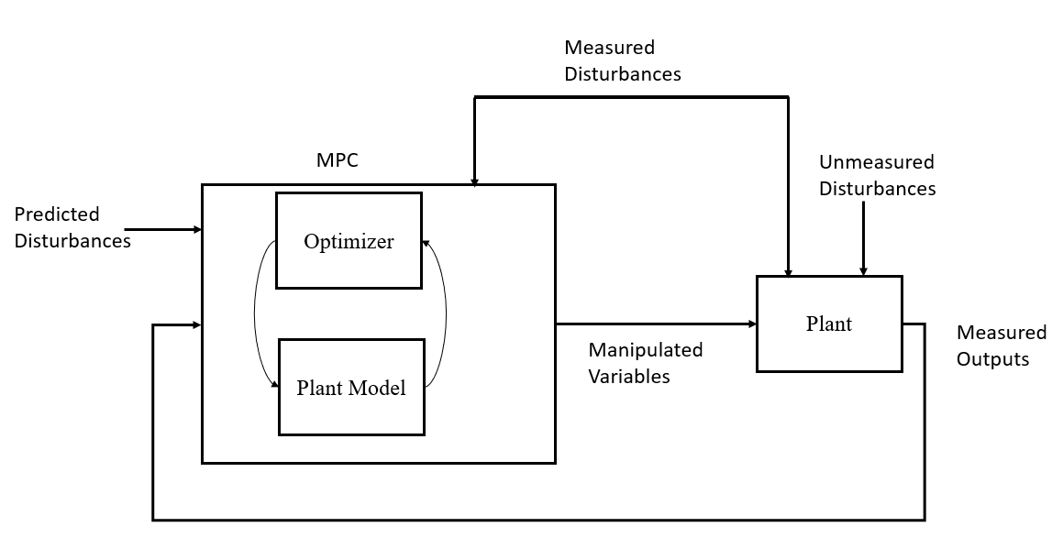

Figure 12: Structure of MPC control strategy

The figure above shows the structure of the MPC control strategy. To understand this structure, various definitions need to be introduced:

* **Plant**: The system that needs to be controlled. In this case the water tank actuated by the heat pump and electric heater.
* **Measured outputs**: The variables in the plant that need to be controlled. In this case, the variables that indicate the energy content of the tank, more specifically, the 5 temperatures across the tank.
* **Unmeasured disturbances**: The variables that influence the plant, but are not taken into account in the modelling process or the measurement system.
* **Measured disturbances**: The external variables that influence the process, but are taken into account in the modelling and the measurement system. In this case: the ambient temperature, the flow rate of water tapping from the tank.
* **Manipulated variables:** The actuators setpoint that are decided by the controller. In this case, the heat pump compressor power and the power of the electric heater.
* **Predicted disturbances:** Predictions of solar irradiation and ambient temperature.

## 5.1 The Optimization problem:

In MPC control strategy, the control signals to drive the heat pump and the electric heaters are obtained by solving an optimization problem at every sampling interval. In effect, every sampling interval k, the control law is decided by running the plant model P steps into the future. The formulation of the optimization problem consists of:

* The Cost function.
* The inequality constraints.
* The equality constraints.

The cost function is given by:

Where:

is the vector of manipulated variables that minimize the cost function over the prediction horizon p.

And u(k) is the vector of setpoints:

The variable represents the deviation between the reference values of the output (The tank temperatures), and the predicted value of the outputs.

Where is the predicted tank temperatures at time k:

And the temperatures T1 to T5 are as defined in the dynamic model presented in the previous section.

Furthermore, represents the deviation of the manipulated variables u(k) from their nominal values at time step k.

The matrices Q and R are weight matrices for the outputs and inputs, respectively. The role of the weight matrices is to “tune” the behavior of the controlled system. For example, assigning a high weight in the matrics Q relative to R will place more emphasis on keeping the temperatures of the tank close to their reference values. Conversely, assigning a high weight in R relative to Q, will place more emphasis on keeping the electric heater and heat pump power close o their nominal values on the expense of allowing the temperatures in the tank to deviate from their reference values.

The optimization problem must be solved while meeting inequality constraints for both the inputs and the outputs. Th e inequality constraints for the inputs follow from the ratings of the actuators, which can be expressed as follows:

Where and are the maximum rating power of the heat pump and the electric heater, respectively. Note that in the controller, for numerical uniformity, the control signals are normalized between zero (for zero power), and one (for maximum power).

The inequality constraints for the output temperatures follow from the health regulations of the DHW [insert reference here]. Water temperatures below 40 C can cause buildup of Legionella bacteria, while temperatures above 60 C can cause scolding burns to the skin. Based on that, the following constraint is adopted:

In addition to the inequality constraints, the solution of the optimization problem must obey the dynamics of the system as described by the model presented in the previous section. The dynamic model describes the evolution of the temperature in the water in the tank. When the model equations are linearized and discretized, they take the form of the equality constraint:

Where A and B are matrices of constants related to the parameters of the system.

## Tuning the MPC parameters:

From the brief exposition above, it can be seen that the performance of the MPC is influenced by the following tunable parameters:

* The controller step size (the sampling time).
* The prediction horizon p.
* The control horizon c.
* The outputs weight matrics Q.
* The inputs weight matrics R.

### 5.2.1 The controller sampling time:

The choice of the controller sampling time depends on several factors; The dominant time constants of the process, the characteristics of the actuators, and the available processing power. The choice of the sampling time should be small enough to capture the process dynamics. However, a very small sampling time is not preferable for the controller, since this will lead to excessive switching (movement) of the actuators (for example excessive change in the compressor setpoint). In addition, a very small sampling time will require the collection of large amount of datapoints to predict the same sampling interval compared to a larger sampling time. For example, if the sampling time is chosen as 1 second, then it will require 3600 data points to predict the next hour, while the same prediction horizon (1 hour) can be achieved with 60 datapoints if the sampling interval is reduced to 1 minute. Therefore, the controller sampling time is chosen as 10 minutes.

### 5.2.3 The prediction horizon p:

A similar argument can be made about the choice of the prediction horizon p. Considering the major disturbances in this process, namely; The solar irradiation (which affects the availability and the price of electric energy), the ambient temperature (which directly affects the COP of the heat pump) and the hot water tapping profile (which directly affects the thermal energy content of the tank). The first two disturbances do not – usually- change significantly in the time scale of seconds to few minutes (Unless shading occurs). Furthermore, the thermal energy content of the water within the tank does not change significantly when there no tapping (For the majority of the day, there is no tapping). Therefore, choosing a prediction horizon of a few minutes will cause redundancy in the computations. In this work, a prediction horizon of 2 hours (12 samples) is chosen.

### 5.2.4 The control horizon c:

Control horizon c : At each controller sampling interval, the optimization problem described in the previous section is solved, the solution yields the controller “moves” for the next p interval (i.e a vector of p elements representing the controller moves). The control horizon refers to how many of these moves are actually sent to the controller. For instance, if the control horizon is set to c=1, only the next controller move is sent to the actuator, while the rest is discarded. If the control horizon is set to c =p, then all the next p controller moves are determined at the current time step. In this application, the control horizon is set to 1. This allows the controller to respond to deviations between the predicted disturbances and the actual disturbances.